OO Analysis & Design Lab 7

# Purpose of Lab: To analyse text for the purpose of identifying concepts and their relationships.

# Instructions :

* Use only one document for your answers.

# For each relationship identify its properties.

Consider the meaning of relationships you create between two classes in terms of its multiplicity, navigability. Label your associations indicate their direction. Consider using role names where appropriate.

# Example

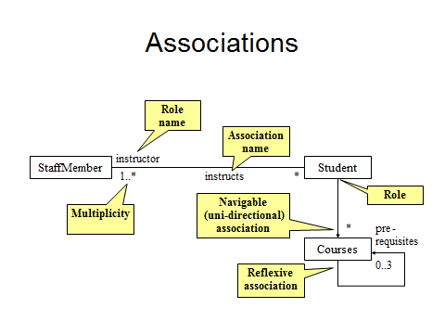

Questions

Q1 Create a number of classes related by associations to represent the situations below.

Take care to specify appropriate multiplicity, as well as labels for the associations. Consider concepts that are not explicitly stated If there is more than one reasonable alternative explain the advantages and disadvantages of each. Use Visual paradigm to draw your answers.

1. *Vehicles possessing wheels*
2. *A video rental shop, where you must purchase a membership before renting something.*
3. *Countries and their heads of state.*
4. *A student taking courses in a school.*
5. *People registering for fitness activities at a gym*
6. *A library lending books to patrons*
7. *A repertory theatre company planning presentations of various plays.*

------------------------------------------------------------------------------------------------------------

Q2. Explain the consequences of the associations in the above exercise in terms of the creation and construction of instances. Consider which class should be responsible for the creation of instances of the other class. Think about the order in which instances can be created and destroyed. Use the multiplicity property of associations to assist you.

-----------------------------------------------------------------------------------------------------------

Q3 Add association classes to the three many-to-many associations in the following diagrams. Show attributes that might be found in these association classes



--------------------------------------------------------------------------------------------

Q4 What type of associations are used in the following diagram? Describe their meaning.

* In symmetric reflexive associations the roles at either end are identical.
* In asymmetric reflexive association the roles at either end are different.

symmetric relationship

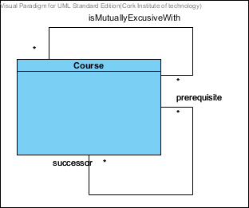

asymmetric

--------------------------------------------------------------------------------------

Q5 Add Association classes to the two many-to -many associations in the diagram in question 4. Show attributes that might be found in these association classes.

---------------------------------------------------------------------------------------

Q6 Apply the transformation shown in the figure below to your answer in question 5.

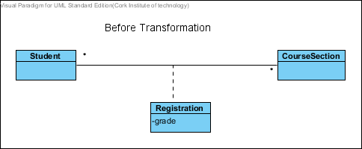

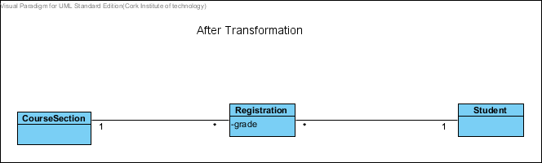

--------------------------------------------------------------------------------------------

Q7 An organization has three categories of employees: professional staff, technical staff and support staff. The organization also has departments and divisions. Each employee belongs to either a department or a division. Draw a class diagram corresponding to this description. Assume that people will never need to change from one category to the other.

Modify the model to allow for people to change categories. You can assume that an employee will ever be in one category.

--------------------------------------------------------------------------------------------

Q8

1. For the following description determine the nouns and noun phrases that might , in the end become classes. Choose good names for the potential classes
2. Build a complete class diagram with associations and attributes as well as generalizations.

***Bank Accounts management System***

*This system provides the basic services to manage bank accounts at a bank called OOBank. OOBank has many branches, each of which has an address and branch number. A client opens accounts at a branch. Each account is uniquely identified by an account number; it has a balance and a credit or overdraft limit. There are many types of accounts; including a mortgage account(which has a property as a collateral), a chequing account, and a credit card account(which has an expiry date and can have secondary cards attached to it). It is possible to have a joint account(e.g. for a husband and a wife). Each type of account has a particular interest rate, a monthly fee and a specific set of privilege)e.g. ability to write cheques ,insurance for purchases etc.) OOBank is divided into divisions and subdivisions (such as planning, investments and consumer0; the branches are considered subdivisions of the consumer division. Each division has a manager and a set of other employees. Each customer is assigned a particular employee as his or her ‘personal banker’*

--------------------------------------------------------------------------------------------